Lab 03

Ques 1: Write a LEX program to get a binary input and print whether the given input is a power of two or not.

*zero [0]\**

*one [1]*

*%%*

*{zero}{one}{zero} {printf("Correct\n");}*

*%%*

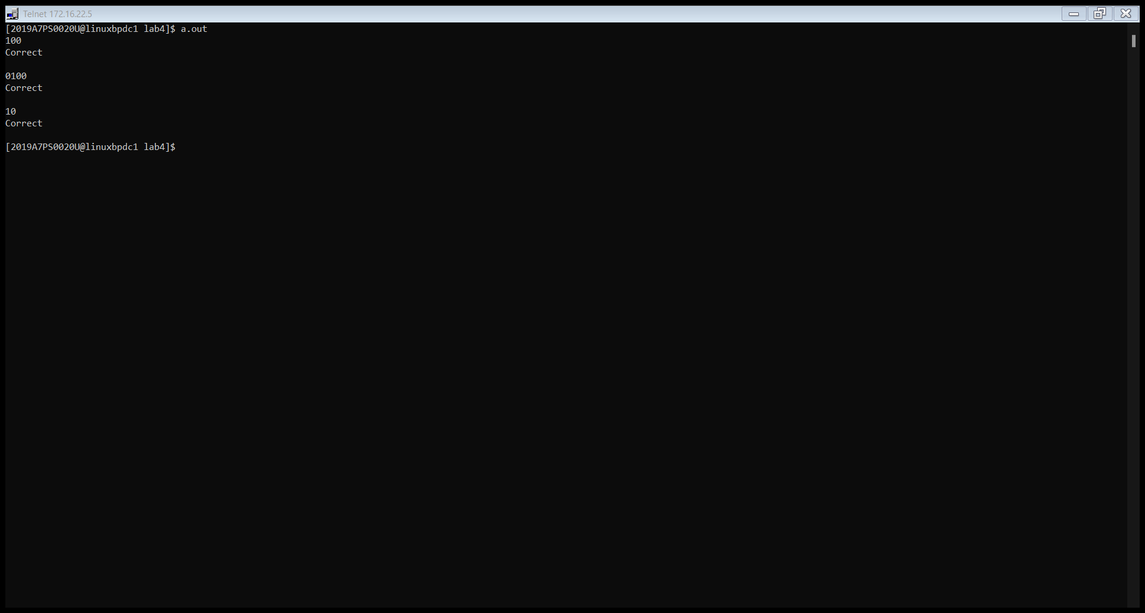

Any power of 2 would have 1 only once at any place followed and preceded by any no of zeroes. Hence grammar would be 0*10*.

Ques 2: Write a LEX program to insert line numbers to a file. For this copy your favourite C program “input.c” to your folder which would be the input to your LEX program.

*%{*

*int count = 2;*

*%}*

*%%*

*"\n" {fprintf(yyout, "\n%d ",count);*

*count++;*

*}*

*. {fprintf(yyout, "%s", yytext);}*

*%%*

*int main()*

*{*

*extern FILE *yyin, *yyout;*

*yyin = fopen("input.txt", "r");*

*yyout = fopen("output.txt", "w");*

*yylex();*

*return 0;*

*}*

The compiler recognizes new line using “\n” and adds a line no before the starting of the line and the *count* variable is incremented for next iteration.

|  |  |
| --- | --- |
| Telnet 172.16.22.5 | Telnet 172.16.22.5 |

Ques 3: Write a LEX program to save the contents of an input file excluding comment lines to another file.

*%{*

*%}*

*word[a-z,A-Z," "]*

*slash[/]*

*newline[\n]*

*%%*

*{slash}""{slash}""{word}+""{newline} {fprintf(yyout, "\n");}*

*. {fprintf(yyout, "%s", yytext);}*

*%%*

*int main()*

*{*

*extern FILE *yyin, *yyout;*

*yyin = fopen("input_comment.txt", "r");*

*yyout = fopen("output_comment.txt", "w");*

*yylex();*

*return 0;*

*}*

Upon seeing //, the compiler puts a newline and moves to the next line.

|  |  |
| --- | --- |
| Telnet 172.16.22.5 | Telnet 172.16.22.5 |

Ques 4: Write a LEX program that would take a BITS student's roll number as input and prints the details of the student based on that. You are expected to write regular expressions that would synthesize information like, year of joining, specialization, PS/Thesis, Registration index, Campus (U) etc. from the given roll number. If the given input does not abide by the Roll number format, print some error message.

*%{*

*#include<stdio.h>*

*#include<string.h>*

*char a[13];*

*%}*

*year [0-9]+*

*stream [AA,A1,A7]+*

*id [0-9]+*

*type [TS,PS]+*

*Campus [P, U, G, H]+*

*%%*

*{year}""{year}""{year}""{year}""{stream}""{type}""{id}""{id}""{id}""{id}""{Campus} {printf("Correct\n");*

*strcpy(a, yytext);*

*printf("Year: %c%c%c%c\n", a[0],a[1],a[2], a[3]);*

*char stream1[10];*

*if (a[5]=='A'){strcpy(stream1, "Electrical");}*

*else if (a[5]=='1'){strcpy(stream1, "Mechanic");}*

*else {strcpy(stream1, "Computer");}*

*printf("Stream: %s\n",stream1);*

*char type1[15];*

*if (a[6]=='P'){strcpy(type1, "Practice");}*

*else {strcpy(type1, "Theory");}*

*printf("Type: %s\n",type1);*

*printf("Roll no: %c%c%c%c\n",a[8],a[9],a[10],a[11]);*

*char campus1[15];*

*if (a[12]=='P'){strcpy(campus1, "Pilani");}*

*else if (a[12]=='G'){strcpy(campus1, "Goa");}*

*else if (a[12]=='H'){strcpy(campus1, "Hyderabad");}*

*else {strcpy(campus1, "Dubai");}*

*printf("Campus: %s\n",campus1);*

*}*

*. {printf("Incorrect\n");}*

*%%*

Various if conditions check the id for stream, type and campus.

